Figures

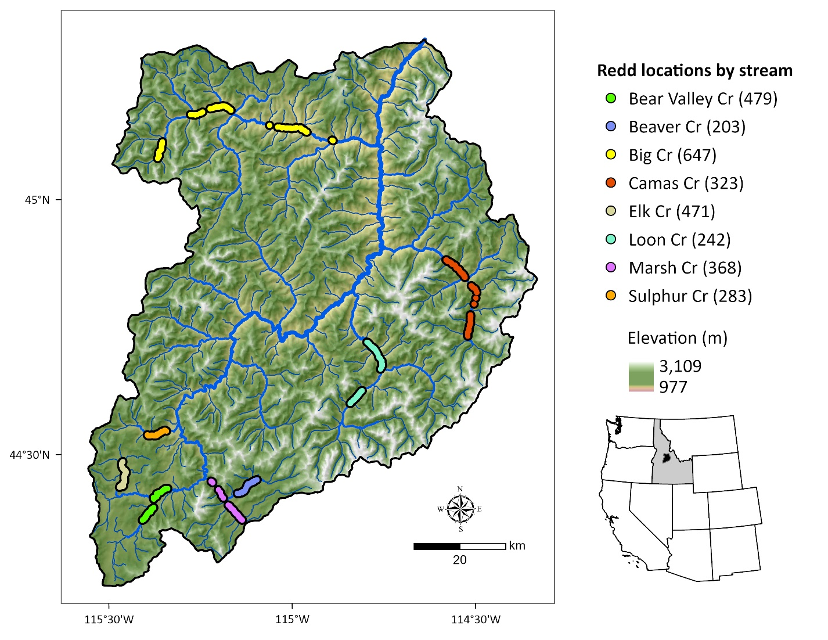Figure 1. Middle Fork Salmon River watershed illustrating major tributaries and surveyed segments containing georeferenced Chinook salmon redds from 2002 to 2005 (count of redds per stream in parentheses). Point locations were dissolved for visualization.

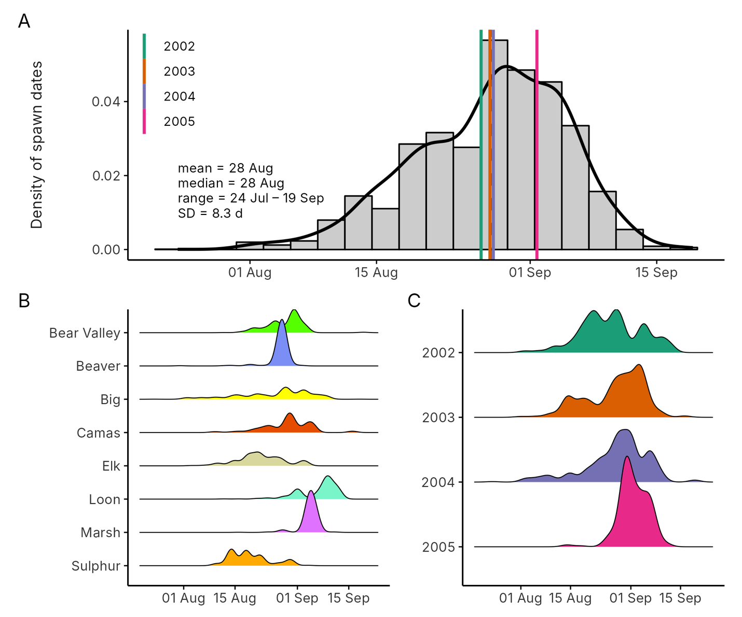
Figure 2: Histogram and density of Chinook salmon spawn timing across all streams and years (A), by stream (B), and by year (C). In panel (A), colored vertical lines show year-specific means, the dashed line the overall mean, and the inset text the overall mean, median, range, and SD. Spawn timing was generally unimodal, peaking in late August to early September.

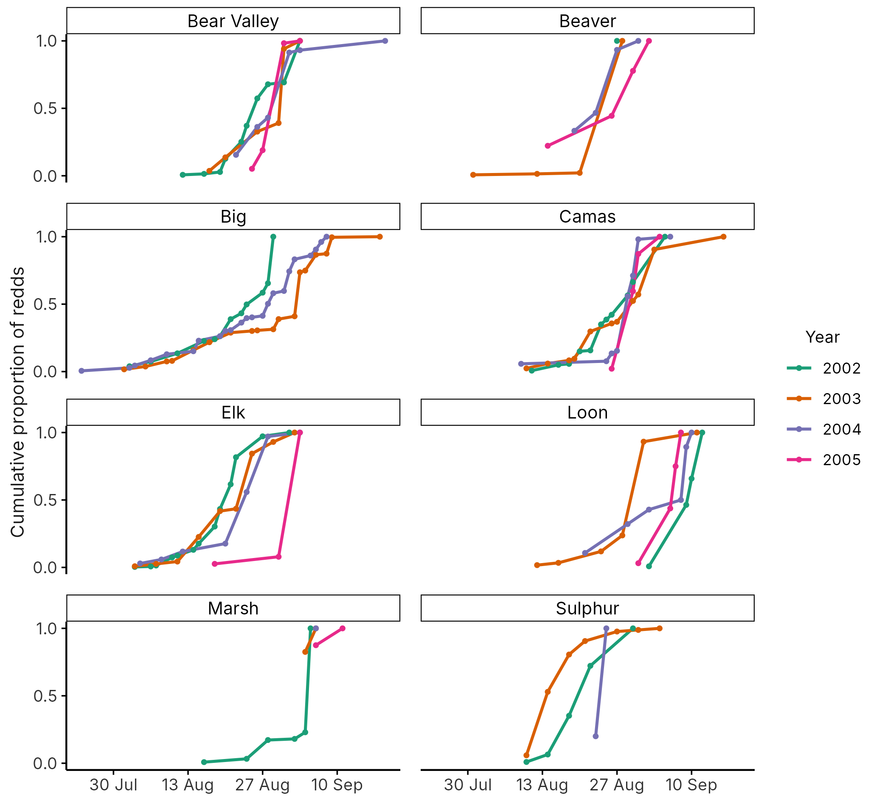
Figure 3. Cumulative proportion of Chinook salmon redds by date in each stream year (2002–2005). Each year is a line. line represents a different year, denoted by color. Cumulative counts are normalized to the total in each stream-year. From 2003 to 2005, only 2, 1 and 2 redd surveys, respectively, were completed in Marsh Creek.

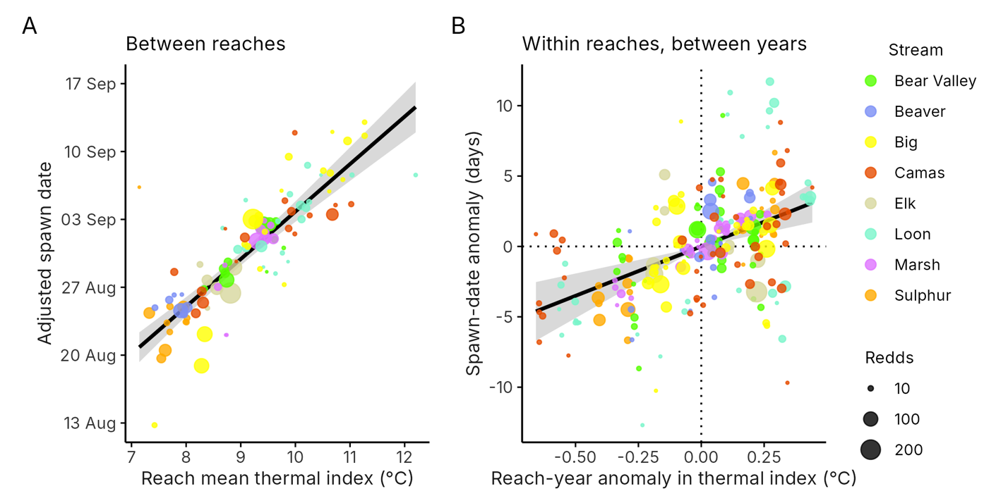
Figure 4. Spawn timing in relation to the thermal index (mean modeled stream temperature, 18 May–16 July). (A) Between reaches: mean spawn date of each reach, adjusted for stream, year and the reach-year anomaly, against the reach mean index (T̄); point size shows the number of redds. Line and band: final-model prediction and 95% CI at average stream and year. (B) Within reaches, between years: for the 77 reaches with redds in two or more years, each reach-year's departure in adjusted mean spawn date from that reach's mean, against its departure in the index (T − T̄). Line and band: within-reach slope and 95% CI.

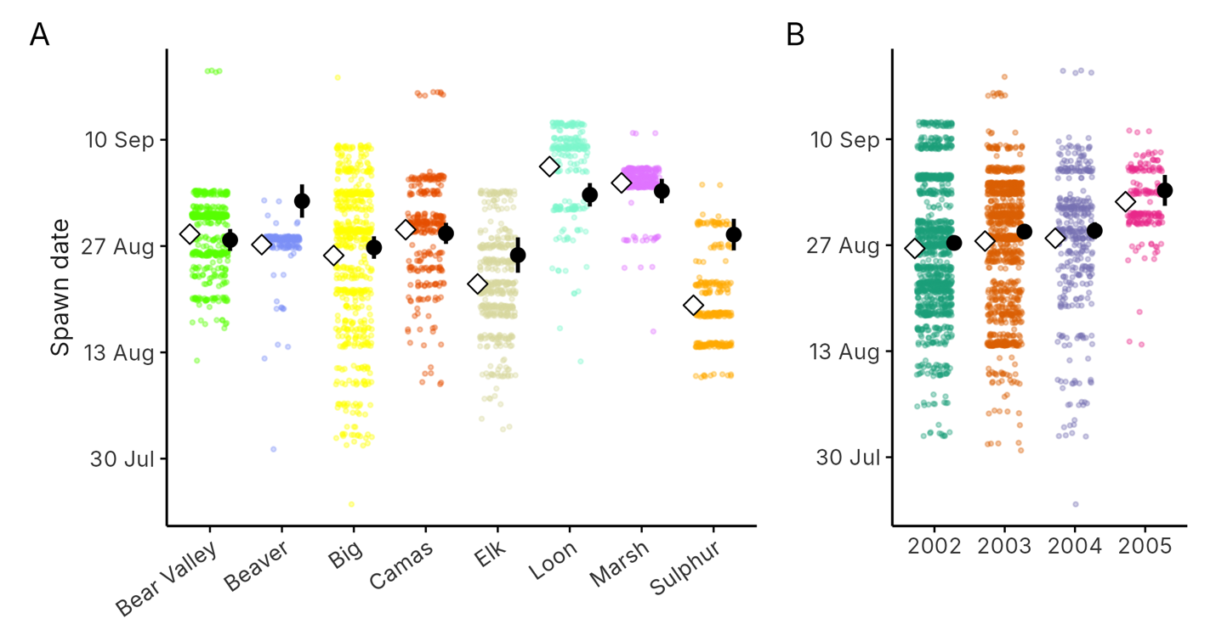
Figure 5. Observed and temperature-adjusted mean spawn dates by stream (A) and year (B). Colored points: individual redds. Open diamonds: observed means. Black points and bars: marginal means and 95% CIs from the final model, at the average reach temperature and averaged over the other factor. The gap between the two shows how much of a stream's or year's timing reflects its temperatures.

